WEB DESIGN AND DEVELOPMENT (WEEK #5)

MOOD BOARD

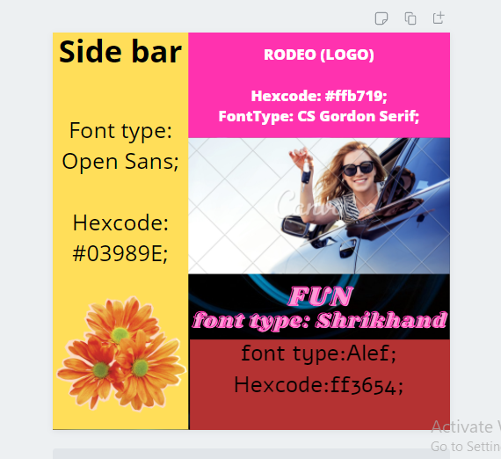

WIREFRAME

